Functional Specification

Standout Campaigns

Table of Contents

1 PERMISSION CONTROL 2

2 BLACK OR WHITE TEXTS 2

3 LANDING PAGE STRUCTURE 3

3.1 HEADER 4

3.2 FEATURED CAMPAIGN SHOWCASE 4

3.3 FILTER BAR(ORANGE BAR) 4

3.4 OTHER/LATEST CAMPAIGNS LIST 6

4 DETAIL PAGE STRUCTURE 7

4.1 HEADER 8

4.2 MAIN INTRODUCTION 8

4.3 FULL WIDTH IMAGE OR VIDEO PANEL 9

4.4 ADDITIONAL INFORMATION 9

4.5 FULL WIDTH IMAGE PANEL 10

4.6 PROJECT TEAM MEMBERS 10

4.7 BRAND TEAM’S VIEW 11

4.8 NEXT/PREV PANEL 11

5 SHOWCASE MAINTAINENCE 11

6 DIFFERENCES BETWEEN OMOBONO’S DESIGN AND OUR WORK 12

6.1 Submission Process 12

6.2 Most popular showcase 12

6.3 Only one quote in the additional information 12

6.4 Maximum number of project memebers 12

6.5 Brand Team’s View 13

6.6 Related Campaigns 13

# PERMISSION CONTROL

* All login users can view this page
* Brand team members, agency users and Accenture internal team can maintain campaigns in backend

# BLACK OR WHITE TEXTS

When add a new showcase, user needs to select a primary color and secondary color for the showcase, all the selectable colors are Accenture Branded Colors. Because some colors are not allowed to put black or white texts on it, for example white texts should not be displayed on “Ice Blue”, black texts should not be displayed on “Ink Blue”. So there is a colors list in the backend where Brand team can maintain all branded colors and their different properties. There is one property “Preferred Font Color”, it can be set either to “Black” or “White”. So for showcase page, if there are texts displayed on primary or secondary color, whether to use black or white texts is depends on the value of “Preferred Font Color”. Below is an example about this:

In landing page featured campaign showcase part, its background color is primary color, so if user choose “Ice Blue” as the primary color, then it should use black texts

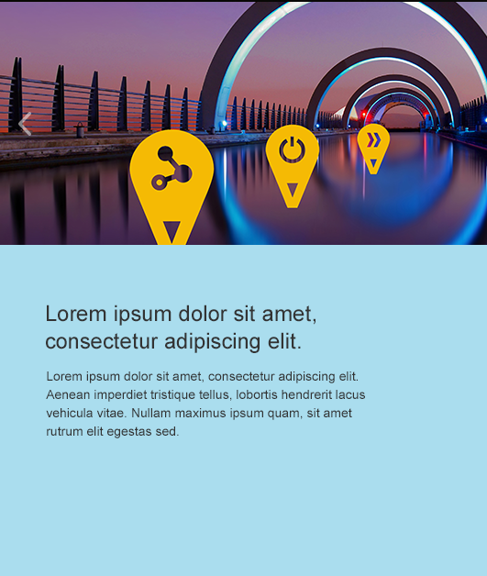

If user choose “Ink Blue” as the primary color, then it should use white texts

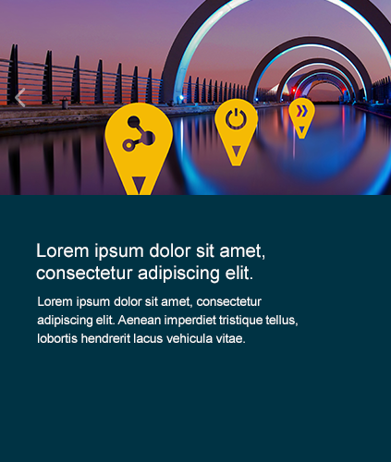

# LANDING PAGE STRUCTURE

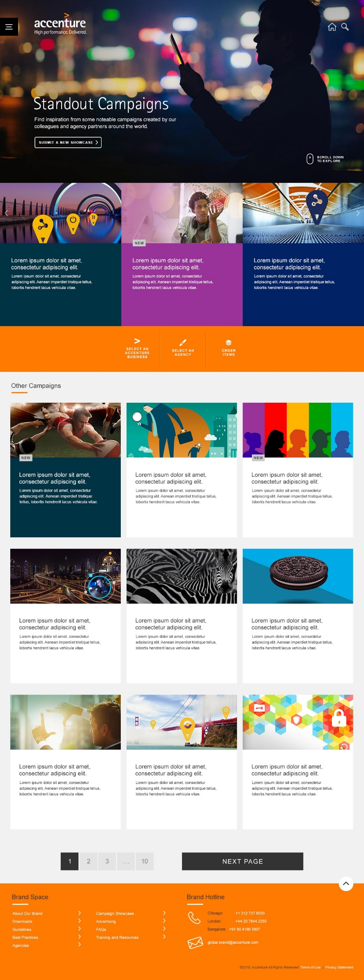

Standout Campaigns landing page is consist of below sections:

* Header
* Featured Campaigns
* Filter bar(Orange bar)
* Other/Latest Campaigns list
* Footer

## HEADER

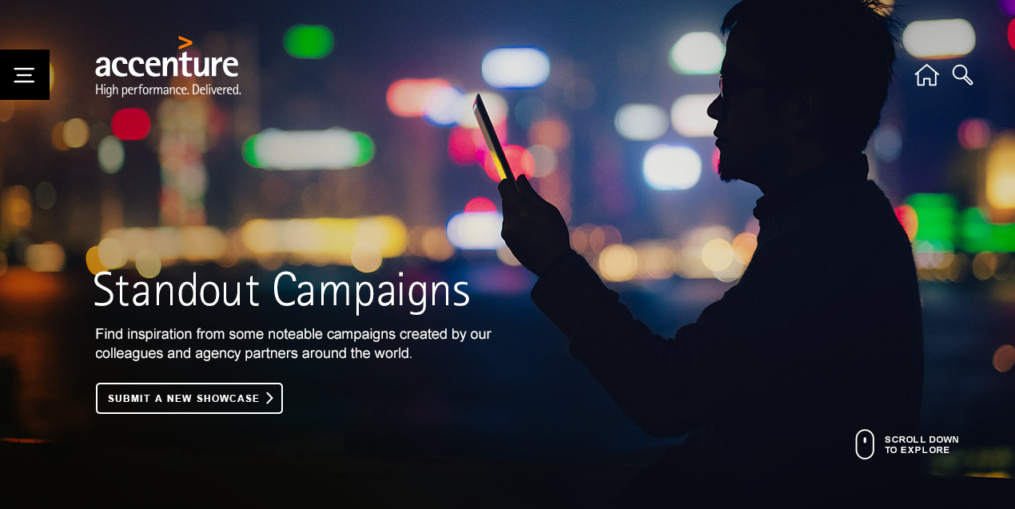

Follow the same style through the whole site, title text is “Standout Campaigns”, and there is a description under the title, its conetnt is “Find inspiration from some noteable campaigns created by our colleagues and agency partners around the world.”. There is one “SUBMIT A NEW SHOWCASE” button, click it will show a popup window which has the instructions about how to submit a new showcase.

## FEATURED CAMPAIGN SHOWCASE

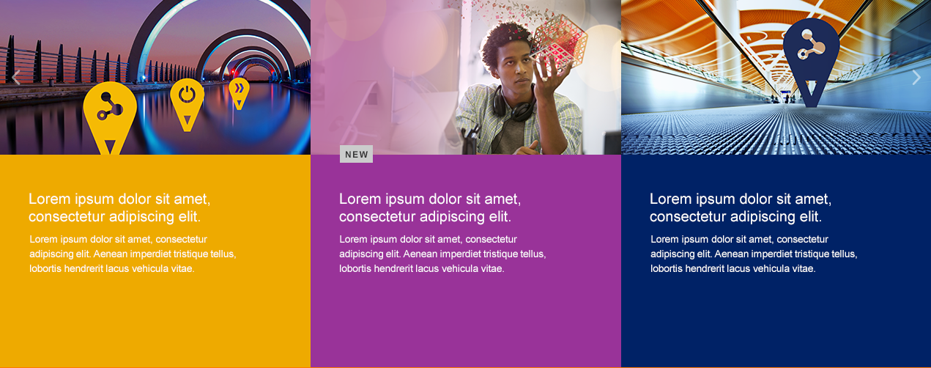

This section pulls 12 showcase randomly from the featured campaign showcase pool, and disply them as a carousel. Each showcase tile is consist of below elements:

* The hero image thumbnail on the top
* The showcase title and description. Its background color is the primary color user selected when add the showcase. Refer to “BLACK OR WHITE TEXTS” about whether to use white or black texts.
* If the showcase was approved in rencent two weeks, then there will be a “NEW” label

Hover the showcase tile, the hero image will zoom 120%, become black and white and then blur, background color will be changed to white and font color will be changed to black.

The featured campaign showcase section is only displayed when there is no filter applied, if one filter is applied, then this section will be disappear.

## FILTER BAR(ORANGE BAR)



There are three filters: “SELECT AN ACCENTURE BUSINESS” and “SELECT AN AGENCY” and “ORDER ITEMS”­

Click one filter option will open its options list







“SELECT AN ACCENTURE BUSINESS” AND “SELECT AN AGENCY” option values depend on what showcase do we have in the result list, for example, if there is no Accenture Consulting showcase in the list, then “Accenture Consulting” will not be included in the the Accenture business options.

“ORDER ITEMS” has three options:

A – Z: list the showcase by title ascending order

Z – A: list the showcase by title descending order

NEWEST: list the showcase by approved date, newly approved onces will be on the first place

If use clicks one option value, that option will be displayed in the “SELECTED FILTERS” panel, and there is one “CLEAR ALL” button which allows user clear the selected filters.

Lists will be refreshed based on what filters are selected.



## OTHER/LATEST CAMPAIGNS LIST

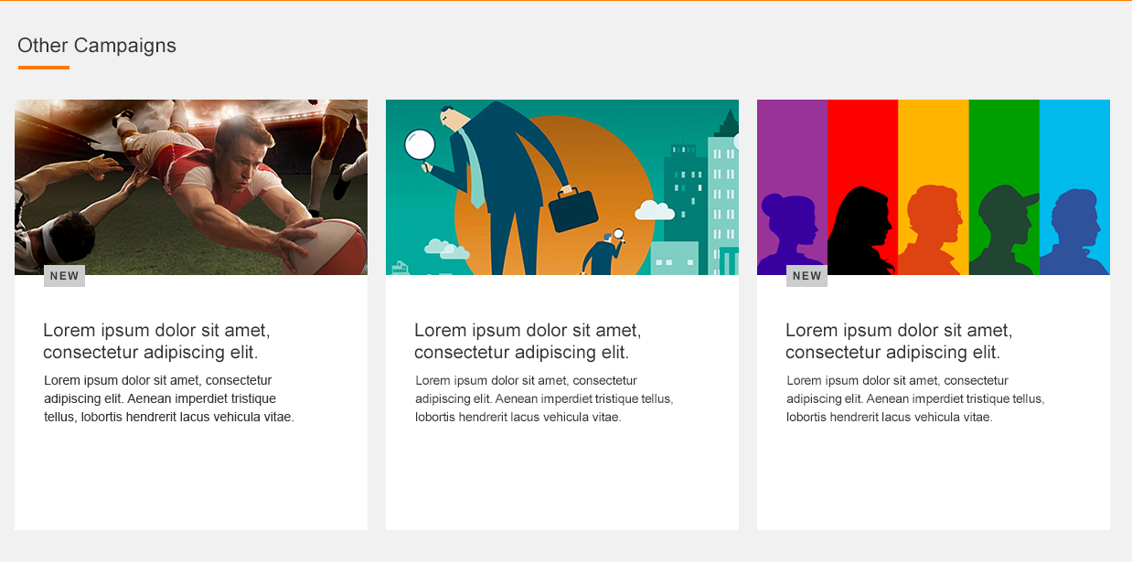

When there is no filter is selected, the list’s title is “Other Campaigns”, and the showcase which are shown in the featured campaigns will not be included in this list. Once a filter is applied, as mentioned in 2.2, featured campaign showcase will be disappear, then the list title will be changed to “Latest Campaigns”, and the filtered result should include all campaigns meet the criteria, no matter they are featured or not.

By default, the showcase are listed order by the approved date, newly approved ones will be on the first place. But if user selects another order by option in “ORDER ITEMS”, the list will be refreshed and ordered by the specified order.

It displays 9 showcase per page, and there is the pagination under the examples list which allows users go to different page of the search result.

Each showcase tile is consist of below elements:

* The hero image thumbnail on the top
* The showcase title and description with black color font and white background color
* If the showcase was approved in rencent two weeks, then there will be a “NEW” label

Hover the showcase tile, the hero image will zoom 120%, become black and white and then blur, background color will be changed to showcase primary color. Refer to “BLACK OR WHITE TEXTS” about whether to use black or white texts.

# DETAIL PAGE STRUCTURE

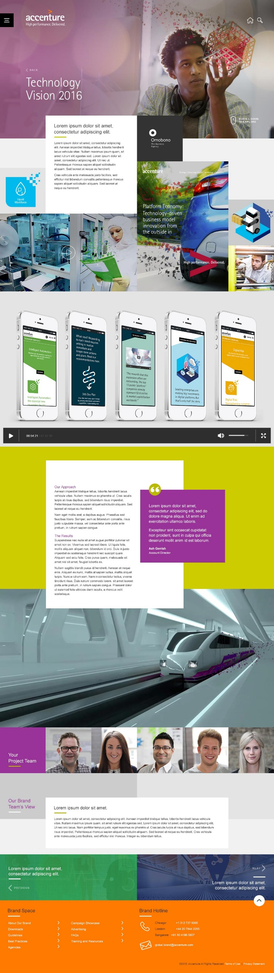

Showcase detail page is consit of below sections:

* Header
* Main Introduction
* Full width image or video panel
* Additional Information
* Full width image panel
* Project team members
* Brand team’s view
* Next/Prev panel
* Footer

## HEADER

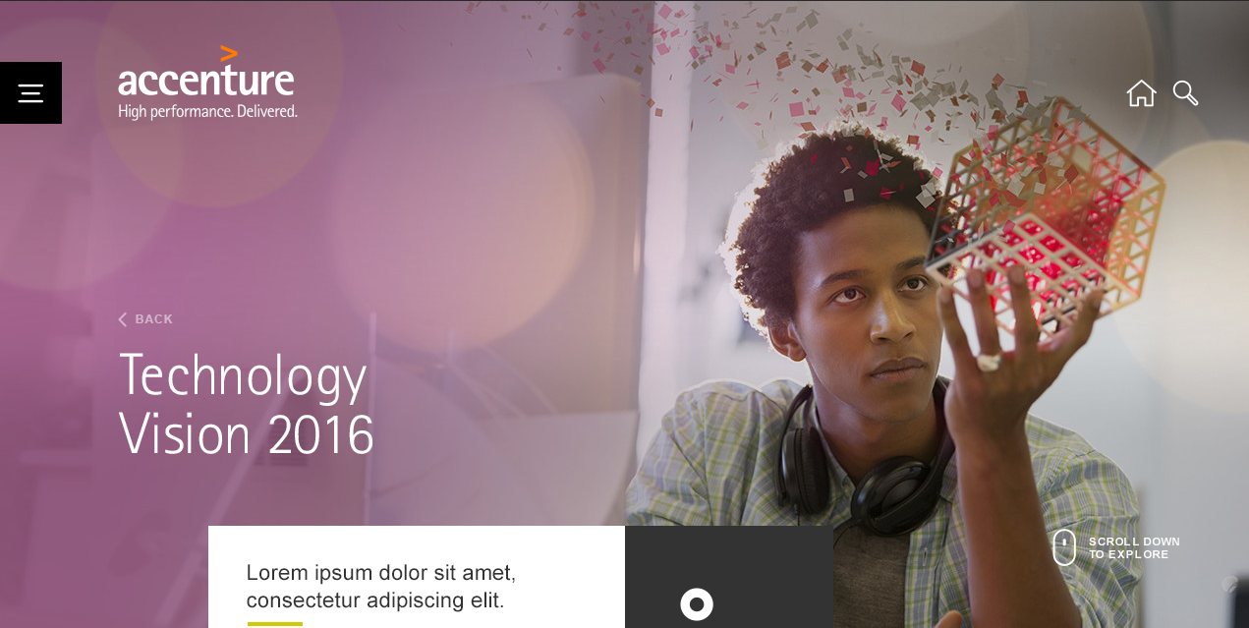

Follow the same style through the whole site, title text is showcase title, click “BACK” link will take user back to the showcase landing page, and previous filter result should be displayed.

## MAIN INTRODUCTION

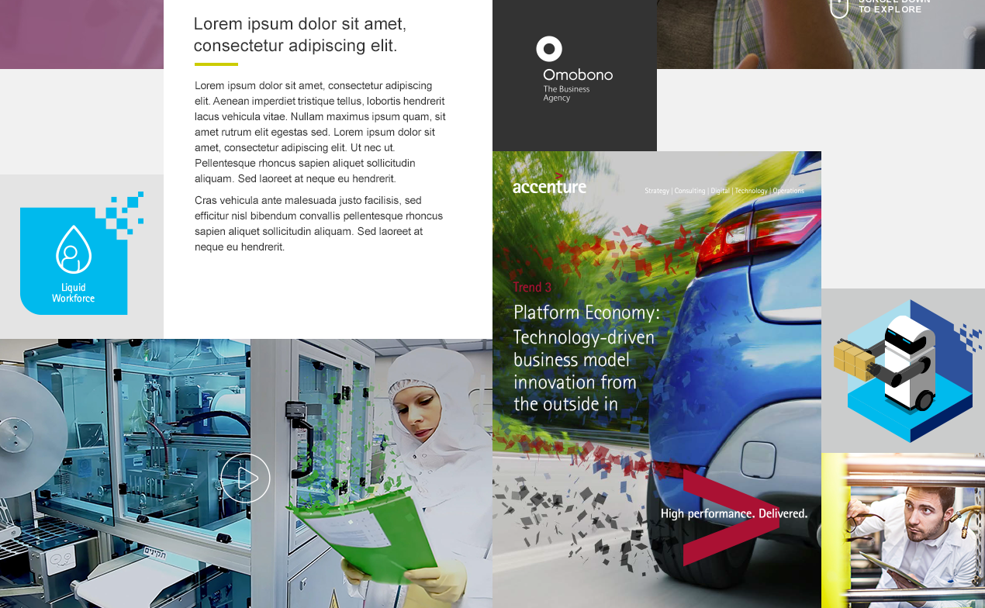

This section includes below information:

* Short description and full description of the showcase
* If the showcase is from agency, then agency Logo should be populated from agency’s profile. If the showcase is from Accenture internal team, then Accenture Logo should be displayed
* Small image boxes which allow user upload images. When user didn’t upload any image for these samll box, it will use primary and second color as the background color, as below screenshot  
  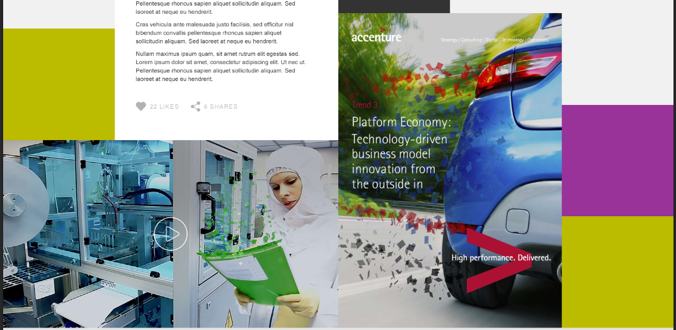
* Image/Video panel which allow user upload image or video(this is a required field)  
  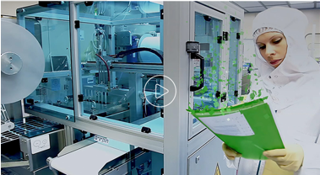
* Carousel panel which allow user uploads multiple images and display them as carousel(this is a required field)  
  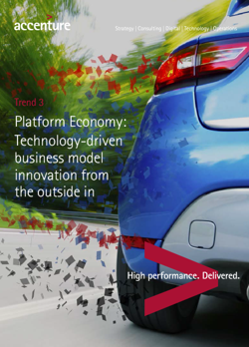

## FULL WIDTH IMAGE OR VIDEO PANEL

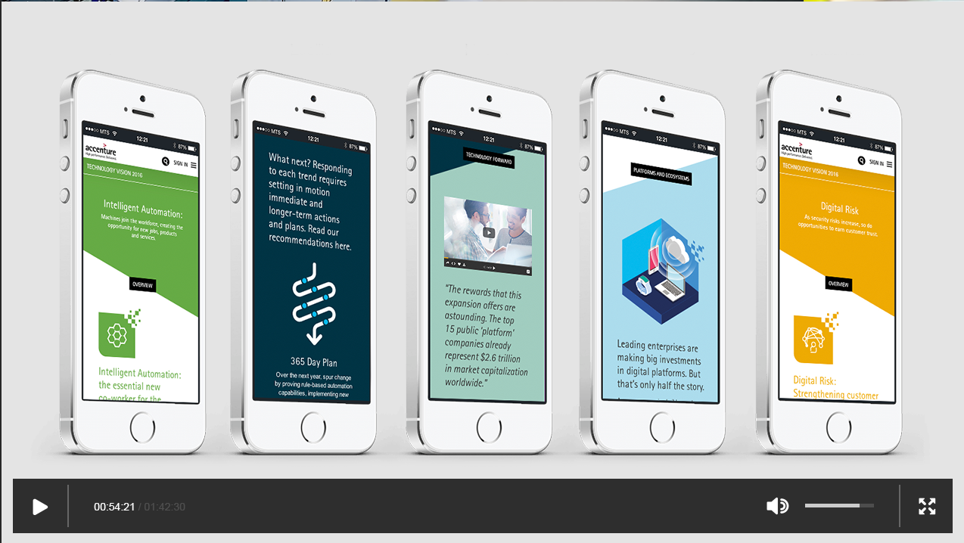

This section allows user upload image or video to display on the page, if user didn’t upload an image or video, then this section will not be shown

## ADDITIONAL INFORMATION

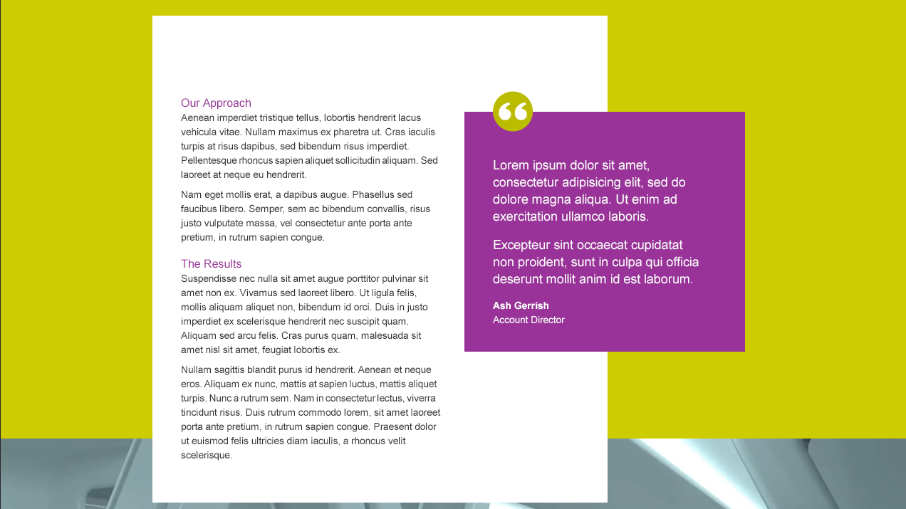

This section is using the secondary color as the background color, displayes below information:

* Our Approach and The Results on white background color
* One quote which background color is the primary color, if user didn’t input a quote content, then the whole quote section will not be shown. The quote icon is within a round which background color is the secondary color.  
  Refer to “BLACK OR WHITE TEXTS” about whether to use black or white quote icon and quote texts.

## FULL WIDTH IMAGE PANEL

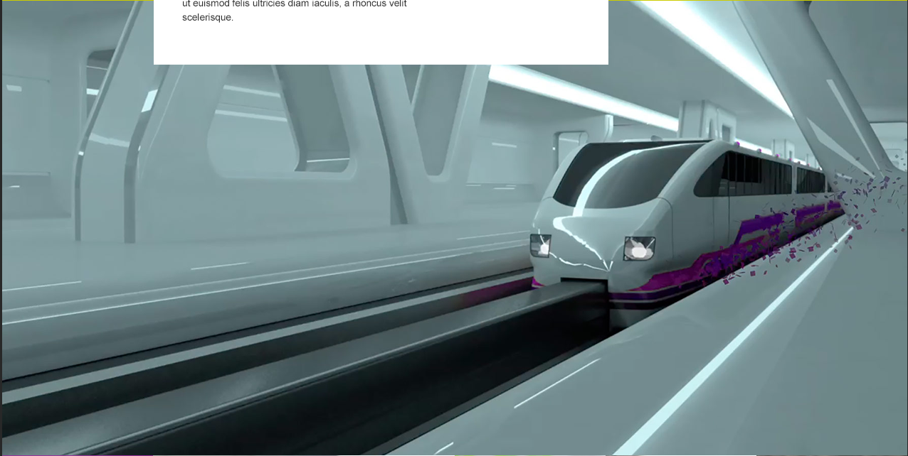

This is a required field that needs user upload an image.

## PROJECT TEAM MEMBERS



“Your Project Team” title’s background is primary color, the short line under it is secondary color. Refer to “BLACK AND WHITE TEXTS” about whether to use black or white texts.

If the showcase is from agency, then the members information will be populated from agency’s profile, if the showcase is from Accenture Internal team, then the members information is input by the user when add new showcase.

When there are less than 5 members, then two different gray panels(#cbcccc, #e4e4e4) will be displayed alternatively as below



If headshort was not uploaded, then it will display the default avatar image.



Hover the headshot will display detail information, includes: name, email, title. If showcase is from agency, then also display agency’s name.

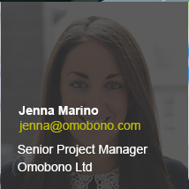

## BRAND TEAM’S VIEW

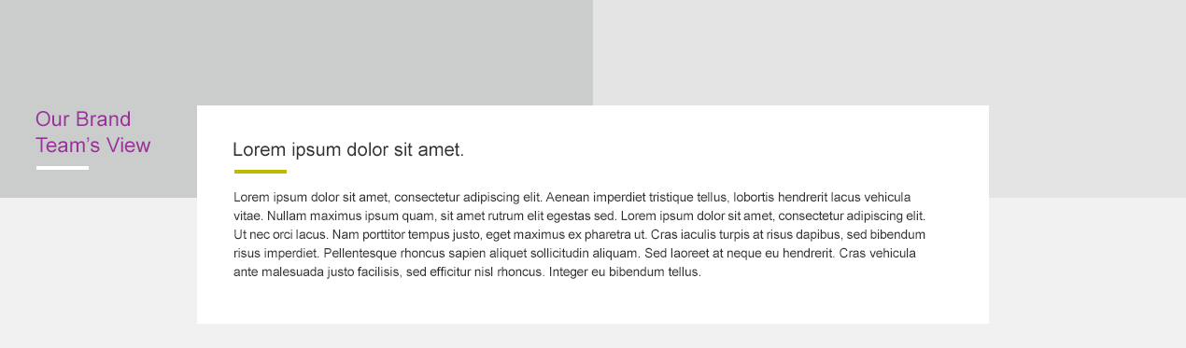

The color of title “Our Brand Team’s View” is primary color. Brand team’s view includes title and details. One short line uder the title which color is the secondary color.

This section’s content will be input by Brand team when they review the showcase.

## NEXT/PREV PANEL

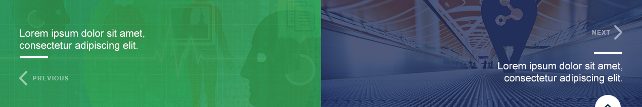

If user enter the detail page from showcase landing page, there will be a next and prev panel which can take user to the next or previous showcase. The background image of the panel is the hero image for the showcase.

If user enter the detail page from site search result list, then the next and prev panel will not be shown.

Showcase’s title will be shown in this panel.

# SHOWCASE MAINTAINENCE

Below are the key points when maintain the showcase

1. Agency needs to have an approved agency profile before add new showcase, so when add a new showcase, they can select their name from the agency profiles dropdown list
2. Accenture Internal Team users need to send mail to [brandspace@accenture.com](mailto:brandspace@accenture.com) to request permission, in the email, they need to provide the internal team name, which users we need to put into the group so all the users can maintain their showcase
3. Both agency and internal team need to have one SharePoint group, agency’s SharePoint group name will start with “Agency”, for example “Agency Omobono”. Internal team’s SharePoint group name will start with “Internal”, for example “Internal Marketing and Communication”. This SharePoint group name will not be shown in the showcase detail page but only be used to control who can maintain the showcase. So when add a new showcase, there is one field “Associated Group” which needs user select their SharePoint group name.
4. Due to lots of images will be uploaded by different people, so if there is one existing image which has the same name as the new uploaded image, user will receive one error message on the page, and they need to change to use another name for the image then upload again, image will not be overwritten.
5. If user wants to save the current input as draft version, then they can choose “No” for “Ready For Approve” and save. If the showcase is ready for Brand team’s review, then user can choose “Yes” for the “Ready For Approve” and save.
6. Once the showcase is submitted for approve, one email will be sent from [brandspace@accenture.com](mailto:brandspace@accenture.com) to the submit user, and cc to the shared mailbox [brandspace@accenture.com](mailto:brandspace@accenture.com). So brand team members will know there is a new showcase needs their review.
7. Once the showcase is approved or reject by Brand team, one email will be sent to all users in the same SharePoint group, so all of users will know their showcase is approved or reject and any of them can maintain the showcase.

# DIFFERENCES BETWEEN OMOBONO’S DESIGN AND OUR WORK

## Submission Process

Previously all users can submit a showcase by clicking “SUBMIT A NEW SHOWCASE” button in the landing page header, but due to SharePoint’s functions limitation, agency needs to have a SharePoint group and profile before they can submit a new showcase, internal team needs to send an email to [brandspace@accenture.com](mailto:brandspace@accenture.com) to request permission, then CIO team needs to create a sharepoint group and add users into that group. After this, they can submit new showcase in the backend. So we will display a instruction popup when user clicks “SUBMIT A NEW SHOWCASE” button.

## Most popular showcase

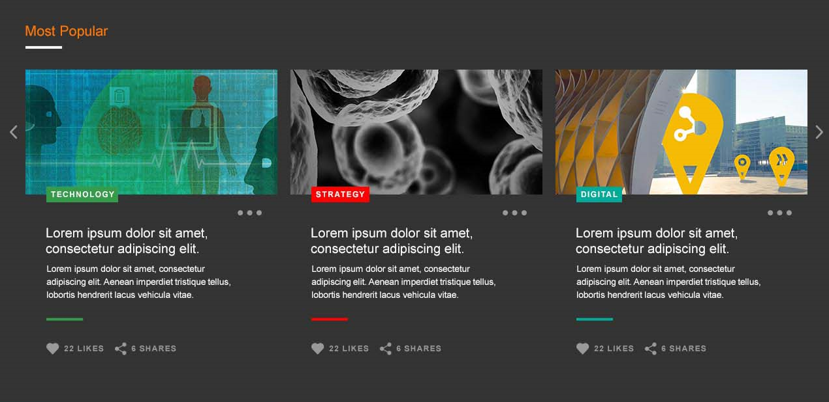

In Omobono’s design, in the showcase landing page, there is one section “Most Popular showcase” which lists top 12 showcase order by # of likes, but due to social media function is not in the scope of initial launch, so we will not have this section on the page

## Only one quote in the additional information

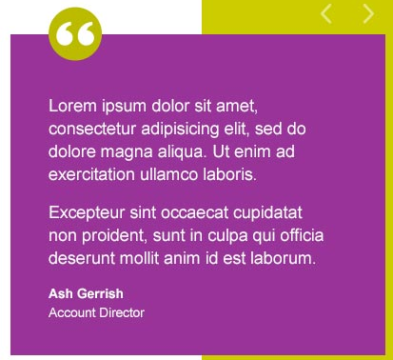

In Omobono’s design, multiple quotes can be added to the additional information part, but as confirmed with Brand team, only one quote is efficient for this

## Maximum number of project memebers

In Omobono’s design, the project team section will be a carousel if there are more than 5 members, but as confirmed with Brand team, 5 members are efficient, so there will not be a case for more than 5 members, so carousel is not needed



## Brand Team’s View

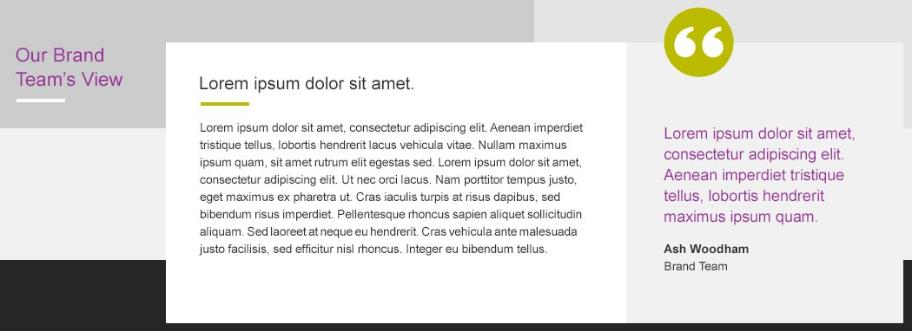

In Omobono’s design, there is one quote in brand team’s view section, but after confirm with Brand team, no quote is needed for here. So we will not have the quote and page will be like below



## Related Campaigns

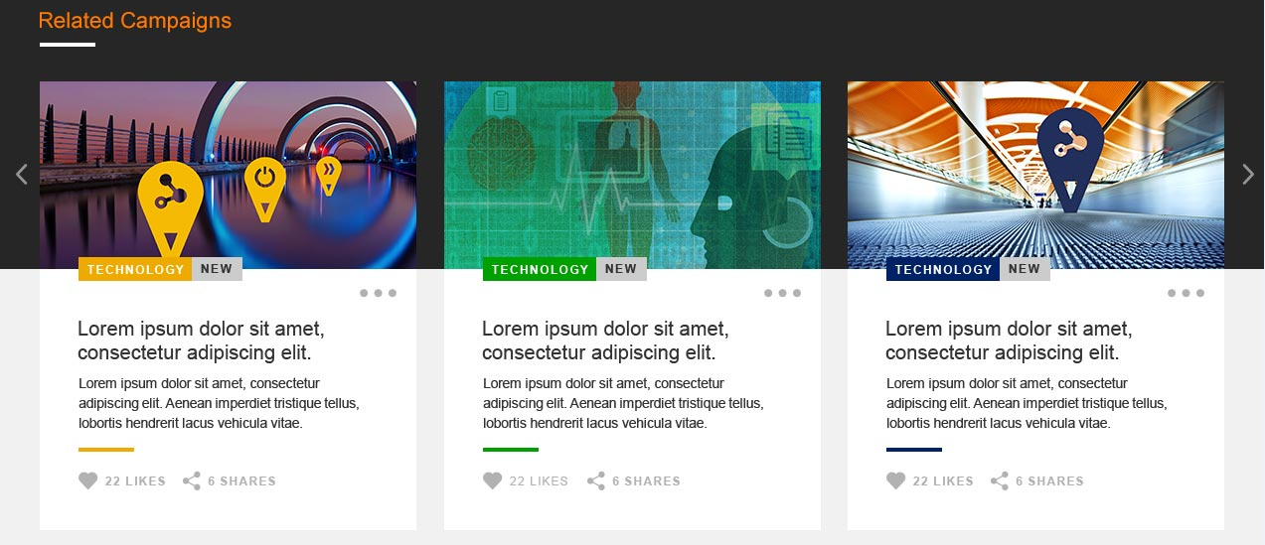

In Omobono’s design, in the showcase detail page, there is one section “Related Campaigns” which shows 12 campaigns under the same category as current showcase, but due to we will not have category for campaign showcase, so we will not have this related campaigns on the detail page.